**“E-Recruit: An Online Recruitment System**

**for Insurance and Investment Agency**

**in Mindoro”**

A Thesis Project

Presented to the Faculty of the

College of Computer Studies

**MINDORO STATE UNIVERSITY**

Calapan City Campus

Masipit, Calapan City, Oriental Mindoro

In Partial Fulfillment

of the Requirements for the Course of

**IT RESEARCH METHOD**

Caibal, Lester M.

Escalera, Jandel L.

Ramos, Jef

BSIT III-F1

November 2023

**TABLE OF CONTENTS**

|  |  |  |  |
| --- | --- | --- | --- |
| **Chapter 1. Introduction** | | |  |
|  | **Project Context ……………………………………………………………………………** | | **1** |
|  | **Objectives of the Study ………………………………………………………** | | **2** |
|  | **Scope and Limitations of the Study …………………………** | | **4** |
|  | **Significance of the Study …………………………………………………** | | **4** |
|  | **Conceptual Framework ………………………………………………………………** | | **6** |
|  | **Definition of Terms …………………………………………………………………** | | **6** |
|  | | |  |
|  |  | |  |
|  |  | |  |
|  |  | |  |
|  |  |  |  |
|  |  |  |  |
|  |  |  |  |
|  |  |  |  |
|  |  |  |  |

**CHAPTER 1. INTRODUCTION**

In this chapter, researcher will delve into the essential aspects of the project that provide a comprehensive foundation for the project ahead.

**Project Context**

Digital technology is continuously evolving and reshaping industries. It has a huge impact on society because it influences the way people access information, communicate, and how people move in this society. In the research context, the critical aspect of conducting the research study involves soliciting information directly from the targeted users. The project context serves as a robust justification for selecting the research problem, emphasizing the researcher's capacity to address challenges. For instance, challenges in managing paper-based documents have been identified. Researchers note difficulties due to inherent risks, including the inconvenience of visiting applicants' residences to collect essential information, thereby introducing complexities to the recruitment process. An Online Recruitment System for Insurance and Investment Agency in Mindoro is crafted with the aim of addressing specific challenges identified in the local context.

The choice of this title is driven by the observed issues associated with managing paper-based documents in the recruitment process. The primary issue to address is the complexity and risk involved in handling physical documents, leading to inconveniences like visiting applicants' residences for crucial information. It is imperative to address this issue to modernize the recruitment process, enhancing efficiency and reducing potential risks and inconveniences. The focus on Mindoro ensures a localized approach, tailoring the system to the unique needs and circumstances of the region.

**Objectives**

The study aims to develop and design an online recruitment system for insurance and investment agents in Mindoro, that will help the employer and applicants of Mindoro to make their transactions faster and easier. The main objective of this study is to improve the overall recruitment experience and become more accurate and efficient.

Specifically, this study is intended to:

1. Implement an online platform for agent applications that accepts electronic forms and signatures.
2. Create a thorough internet recruitment plan to interact and connect with potential agents in far-off places
3. Improve the agent hiring process by giving applicants easy access to online resources and support.
4. Reduce the cost that is associated with the traditional ways in recruiting new employees.
5. Make the hiring process more efficient by having to look on the applicant’s background without even meeting them personally.
6. Having a more efficient way of screening and interview scheduling through online.
7. Use the system to gather information of applicants to and analyze for better decision making.
8. Improve the experience of the applicant by providing them a user-friendly platform when applying.
9. Make a database of potential candidates for future openings.
10. Ensure the system follows the data protection and recruitment regulations.

**Scope and Limitations of the Study**

This study is limited to the aspects and factors of creating, designing, and implementing an Online Recruitment System for Insurance and Investment Agents. The proposed system will accommodate the transactions in recruiting agents only in Mindoro, Philippines. There are three users in the system; the admin, agents, and the applicants. The admin can add or register applicants, as well as the admin can use the system in recruitment, and then the agents can only access the recruitment system, Lastly, the applicants can view the requirements and input information about his/her background information, as well as the applicants can enter and edit information through the online platform using the system.

**Significance of the Study**

The study "E-Recruit: An Online Recruitment System for Insurance and Investment Agency in Mindoro" offers a streamlined and effective method of hiring, which has a big impact for the insurance and investment sector in Mindoro. By demonstrating a dedication to contemporary methods, the development of an online system not only increases the strength of the agency's competitive edge but also makes more cost-effective, more candidate outreach, and higher chances of recruiting good and experienced applicants all around Mindoro. This technological advancement cuts down on the time to employ, guarantees secrecy and adherence to data protection laws, and offers useful data for decision-making. Scholars with a focus on business management, information technology, and human resources can gain valuable understanding of how technology can revolutionize the recruitment process. The results of this research can also be used as a guide for other organizations looking to streamline their hiring procedures in the digital age and also for researchers as a base for the future research that is connected with the topic.

**Conceptual Framework**

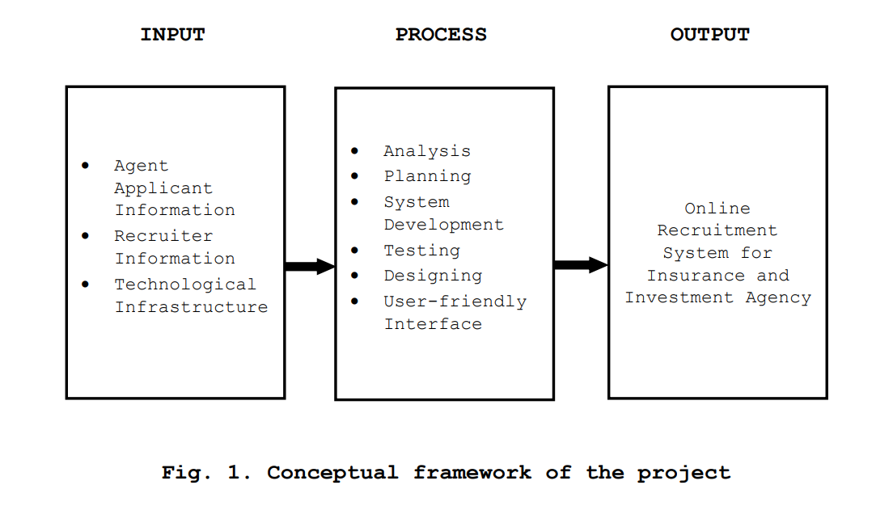

Figure 1, represents the relationships and sequences between these elements, showing how the input is processed through various stages to produce the desired output, which is the Online Recruitment System for the specified agency.

**Definition of Terms**

To facilitate comprehension and enhance clarity, researcher break down and explain the following terms:

**Metrics** - is a quantifiable measure used to assess and analyze the performance and effectiveness of the Online Recruitment System.

**Niche** - is the specific skill set or job market focus of the Online Recruitment System.

**Digital Technology** - is the utilization of electronic devices, software, and online resources to facilitate, and enhance various processes within the Online Recruitment System.

**Recruitment System** - is an integrated set of processes, tools, and technologies designed to manage and optimize the end-to-end recruitment and hiring process. It typically includes functionalities for posting job vacancies, collecting applications, screening candidates, and managing the overall hiring workflow.

**Overshooting** - is the situation where the number of applicants exceeds the available positions.

Toolset - is a collection of software tools and applications integrated into the Online Recruitment System to perform various tasks such as applicant tracking and evaluation.

**Social Media** - is utilized for postings, employer branding, and reaching potential applicants through platforms like Twitter, and Facebook.

**Data-Backed Hiring** - relies on the analysis of data and metrics to make informed decisions throughout the hiring process.

**Online Platform** - is a web-based interface or application that facilitates various recruitment activities, including application submission, communication between agents and applicants, and the management of the hiring workflow.

**Electronic Forms** - is a digital document that replace traditional paper-based forms in the recruitment process.

**Database** - is structured collection of data stored electronically, candidate profiles, and other relevant details.

**REFERENCES**

Edirisinghe, S. M. (2020). *Recruitment Management System*. <https://dl.ucsc.cmb.ac.lk/jspui/bitstream/123456789/4486/1/2017%20MIT%20017.pdf>

Grace, M., Ventura, G., & Bringula, R. P. (2013). *Effectiveness of Online Job Recruitment System: Evidence from the University of the East*. www.IJCSI.org

Kmail, A. B., Maree, M., Belkhatir, M., & Alhashmi, S. M. (2016). An automatic online recruitment system based on exploiting multiple semantic resources and concept-relatedness measures. *Proceedings - International Conference on Tools with Artificial Intelligence, ICTAI*, *2016*-*January*, 620–627. <https://doi.org/10.1109/ICTAI.2015.95>

Malki, Z., Atlam, E., Malki, Z., & Atlam, E. (2021). Graduate Students and Companies Web Based E-Recruitment System. *Journal of Computer and Communications*, *9*(9), 71–84. https://doi.org/10.4236/JCC.2021.99005

Obipi , I. O., & Kalio, N. (2018). Recruitment Management System and Employee Procurement in the Oil and Gas Sector in Nigeria. *International Journal of Human Resource Management and Research*, *8*(2), 7–18. https://doi.org/10.24247/ijhrmrapr20182

Ramadhani, F., & Zarlis, M. (n.d.). *Analysis of e-Recruitment System Design*. https://doi.org/10.17706/ijeeee.2019.9.1.38-45

Rosoiu, O., & Popescu, C. (n.d.). *E-recruiting Platforms: Features that Influence the Efficiency of Online Recruitment Systems*. https://doi.org/10.12948/issn14531305/20.2.2016.05

Samoli, C. (2021, May 20). *How management systems drive value in business operations*. Monday.com Blog. https://monday.com/blog/project-management/management-systems/

Sehgal, V. K., Jagtiani, A., Shah, M., Sharma, A., Jaiswal, A., & Mehta, D. (2014). Job portal-A web application for geographically distributed multiple clients. *Proceedings - 1st International Conference on Artificial Intelligence, Modelling and Simulation, AIMS 2013*, 199–204. https://doi.org/10.1109/AIMS.2013.38

|  |
| --- |
| **Checked and Reviewed by:** |
|  |
| **Mr. Christian I. Cabrera** |
| **ITC311 - Facilitator** |